# CS 255 System Design Document Template

## UML Diagrams

### UML Use Case Diagram

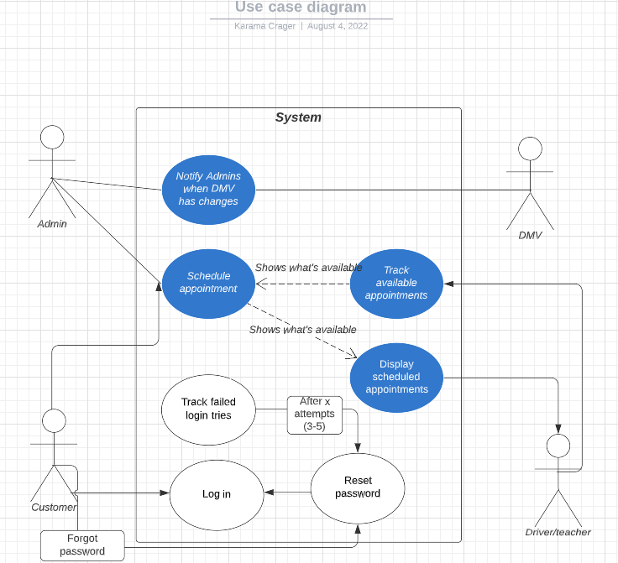

### UML Activity Diagrams

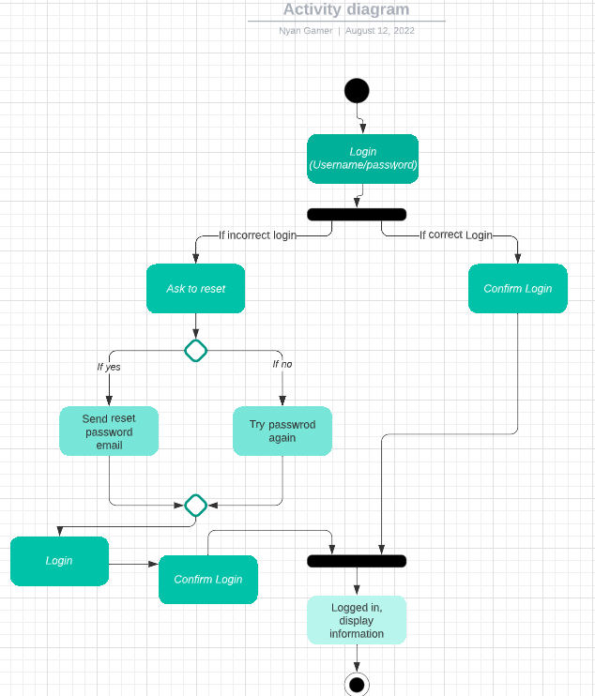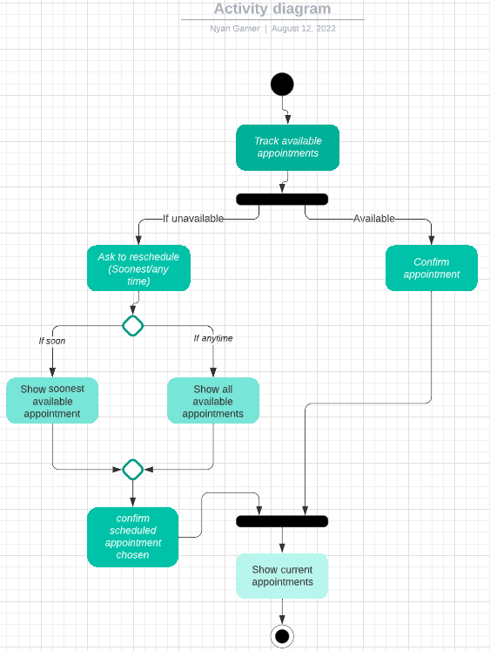

### UML Sequence Diagram

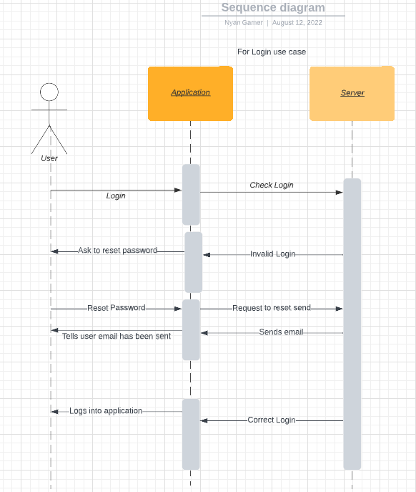

### UML Class Diagram

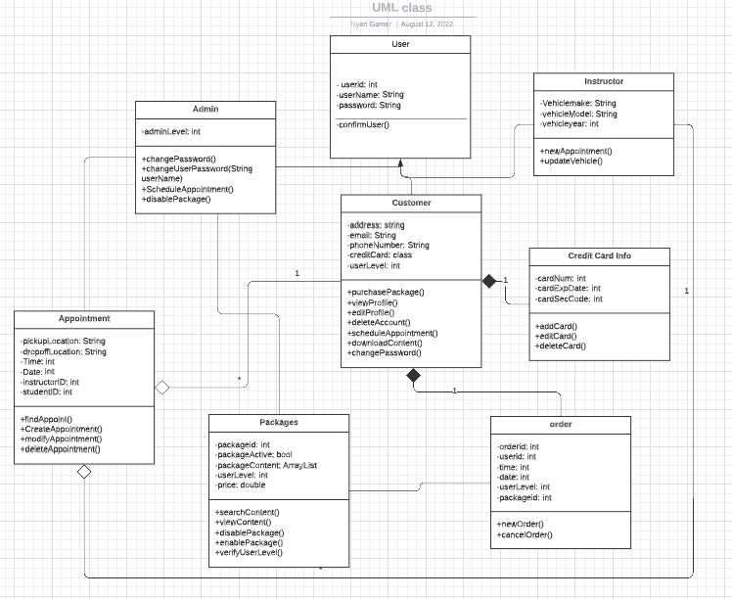

## Technical Requirements

*For the hardware, we’d need a server, monitors, keyboard, mouse, internet connection, and a power source. This would suffice for the hardware needed for the host. For clients, they’d simply need a computer/phone with internet access. If the clients have this, they’ll be able to use the system as required. When looking at the software requirements for the system, I’d recommend windows, as it’s the most widely available and used operating system. If the client chooses to not use a windows operator system for DriverPass, we’d have to use a web browser, which will make it easier to use regardless of the system of the client’s choice. The tools we’d need for this system would be an internet connection and a programming software of the company’s choice (Ex. Visual studio). Looking into the infrastructure, we’d need a cloud provider (unless the company refers to a physical server, which would then need a separate location). After this, we’d need constant power to the server/cloud, with the internet for constant access to it. When looking for the students in this section, we’d need cars for the students and the instructors. The last thing I’d add to the infrastructure would be something to process the credit cards to ensure the money is being accepted and kept track of.*